Health and Safety Policy Statement

It is the policy of Contract Plant (CP) to do all that is reasonably practicable to protect the health, safety & welfare of our employees and other stakeholders who may be affected by our undertaking.

The Directors and Managers of CP are committed to providing a safe and healthy working environment for the prevention of work-related injury and ill health.

CP will endeavour to ensure the provision of an effective Health & Safety management system with supporting arrangements to enable:

- Compliance with all applicable health and safety legislation and other requirements to which the organisation subscribes.
- Systematic risk management programmes based upon the identification of hazards and the development of appropriate preventative and protective controls based on the Hierarchy of Controls to eliminate hazards and reduce OH&S risks.
- Continual improvement in Health & Safety performance through the setting of objectives, targets & key performance indicators.
- Provision of suitable and sufficient training programmes for employees.
- Regular opportunity for open communication and consultation with workers, workers representatives & interested parties to evaluate the effect of their actions, share best practice and raise awareness.

All employees have a legal duty to take reasonable care of their own Health & Safety and others that may be affected by their acts or omissions.

They are required to follow all relevant procedure, codes of practice & guidelines, reporting any matter likely to present danger to management.

This policy and supporting arrangements will be subject to regular review to ensure their effectiveness and that the listed objectives remain appropriate for the business.

Approved By:
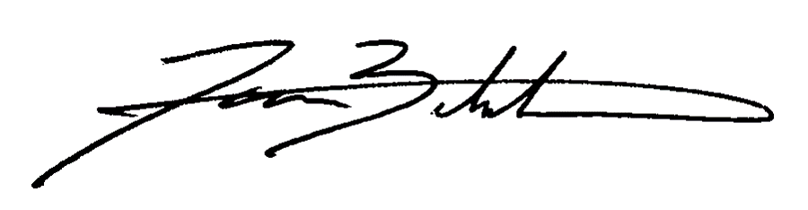
James Bickerton
Managing Director

